**ONLINE REAL ESTATE MANAGEMENT SYSTEM**

**APPLICATION DEVELOPMENT – I**

**SOFTWARE REQUIREMENTS specification**

*Submitted in partial fulfilment for the award of the degree*

*of*

**Master of Technology**

***in***

**Information Technology**

*by*

**Suryakant .K. Dubalgunde**

**(17MIN0395)**



**School of Information Technology and Engineering**

September, 2019

**Table of Contents**

1. INTRODUCTION 4

1.1 PURPOSE 4

1.2 SCOPE 5

1.3 DEFINITIONS, ACRONYMS, and ABBREVIATIONS 6

1.4 REFERENCES 6

1.4.1 BOOKS 6

1.4.2 WEBSITES 6

1.5 OVERVIEW 7

2. GENERAL DESCRIPTION 7

2.1 PRODUCT PERSPECTIVE 8

2.2 PRODUCT FUNCTIONS 9

2.3 USER CHARACTERSTICS 10

2.4 GENERAL CONSTRAINTS 10

2.5 ASSUMPTIONS AND DEPENDENCIES 10

3. SPECIFIC REQUIREMENTS 11

3.1 PRESENT SYSTEM 11

3.1.1 LIMITATIONS 11

3.2 PROPOSED SYSTEM 12

3.2.1 ADVANTAGES 12

3.3 EXTERNAL INTERFACE REQUIREMENTS 13

3.3.1 User Interfaces 13

3.3.2 Hardware Interfaces 13

3.3.3 Software Interfaces 13

*ABOUT TECHNOLOGIES* 16

HTML (HYPERTEXT MARKUP LANGUAGE) 16

JSP ( JAVA SERVER PAGES ) 19

JAV 20

JAVASCRIPT 21

CSS ( CASACADING STYLE SHEET ) 22

SQL ( STRUCTURED QUERY LANGUAGE ) 22

*3.4 FUNCTIONAL REQUIREMENTS* 23

3.4.1 Customer interface functional requirements 24

3.5 USE CASES 27

3.5.1 Customer perspective 27

3.5.2 Administrator perspective 29

Database Admin 29

3.6 NON-FUNCTIONAL REQUIREMENTS 30

3.6.1 PERFORMANCE 30

3.6.2 RELIABILITY 30

3.6.3 AVAILABILITY 30

3.6.4 SECURITY 30

3.6.5 MAINTAINABILITY 31

3.6.6 PORTABILITY 31

3.7 INVERSE REQUIREMENTS 31

3.8 DESIGN CONSTRAINTS 31

3.9 LOGICAL DATABASE REQUIREMENTS 32

3.10 OTHER REQUIREMENTS 35

3.10.1 Allow user to update: 35

3.10.2 Security 36

3.10.3 Administration system: 37

4. ANALYSIS MODEL 38

4.1 Data Flow diagram 39

4.2 ER Diagram 43

5. CHANGE MANAGEMENT PROCESS 44

5.1 FUTURE ENHANCEMENTS 44

5.2 APPENDICES 45

5.2.1 APPENDIX 45

# INTRODUCTION

This Software Requirement Specification document provides a complete description of all the functionalities and the specifications of the Online Real Estate Management System. The developers and the testers can use this document as a reference for developing the design and test plan documents.

## PURPOSE

The Software Requirements Specification (SRS) will provide a detailed description of the requirements for the Online Real Estate Management System (OREMS). This SRS will allow for a complete understanding of what is to be expected of the OREMS to be constructed. The clear understanding of the OREMS and its’ functionality will allow for the correct software to be developed for the end user and will be used for the development of the future stages of the project. This SRS will provide the foundation for the project. From this SRS, the OREMS can be designed, constructed, and finally tested. OREMS help us to maintain the database of various property & agent’s information .It not only help us to maintain the agent information but here we also allow agents to access the portal updated information across the global environment.

If you looking to buy, sell, rent, invest and lease a property then here is the better place to think forward. We know it is a tiring to call individual property agents, arrange appointment, finding better time for appointment and they will assist you .For such complex process we provide a one simple online form which require your basic information and we will assist in short time period.

With features like estate information, valid buyer & seller information this web application turns out to be a very suitable for sellers to find suitable buyers for the estate.

* The system should have a login. A login page should appear when the system is invoked.
* The Admin should have all the type of authority.
* The Admin should maintain property .Admin identify property type as it is residential or commercial property.

* The Admin user can inform their agents about property and update the information regarding property and cancellation of property or changing buyer choice.
* The user should book the property for sell or rent with detail of property.
* The system is very useful for the companies or builders that can post and edit their properties and their personal info and admin can monitor records of all of them.
* The system is also useful to keep track of Account details of buyers(rent) and Sellers(lease)

## SCOPE

OREMS help us to maintain the database of various property & agent’s information .It not only help us to maintain the agent information but here we also allow agents to access the portal updated information across the global environment.

If you looking to buy, sell, rent, invest and lease a property then here is the better place to think forward. We know it is a tiring to call individual property agents, arrange appointment, finding better time for appointment and they will assist you .For such complex process we provide a one simple online form which require your basic information and we will assist in short time period.

With features like estate information, valid buyer & seller information this web application turns out to be a very suitable for sellers to find suitable buyers for the estate.

By automating the property searching, the buyers as well as sellers will be satisfied by the faster, non-tedious, system. Users will get a very quick service by reducing the manual recordings. Also seller will feel comfortable by reduction of their work. Recording errors will be reduced and it is easy to handle a large database. Falsifying of records and details will also be avoided. Considering all these factors we can conclude that all the users and end users will be satisfied by the system.

## DEFINITIONS, ACRONYMS, and ABBREVIATIONS

SRS – Software Requirements Specification

OREMS – Online Real Estate Management System

Subjective satisfaction – The overall satisfaction of the system

End users – The people who will be actually using the system

GUI - Graphical User Interface

## REFERENCES

### BOOKS

To develop the web site certain helps are taken from different books of renowned authors. The references are, therefore, as follows.

* Java2 Complete Reference

Author : Herbert Scheldt

Publisher : TMH , Edition –Seventh

* HTML 5 Black Book

Author : Kogent Learning Solutions Inc.

Publisher : Dremtech press

### WEBSITES

* www.w3school.com (HTML ,AJAX, JavaScript & etc)
* www.roseindia.com
* www.javapractice.com
* www.avajava.com/tutorials
* www.java-samples.com/jsp/
* www.connectionstrings.com/oracle

## OVERVIEW

This SRS document is developed for the development of OREMS. This document will be used as a base document for further project developments.The SRS is organized into two main sections. The first is The Overall Description

and the second is the Specific Requirements. The Overall Description will describe the requirements of the OREMS from a general high level perspective. The Specific Requirements section will describe in detail the requirements of the system.

# GENERAL DESCRIPTION

It has used both structured analysis as well as object oriented analysis for the development of this Software Requirement Specification document. Analysis can be defined as understanding the business needs as well as processing the requirements. We have designed the structural chart, Data Flow Diagram and Entity Relationship diagram for the structured analysis of the project. Similarly we have developed Class Diagrams, Use case diagrams and Activity diagrams for the Object Oriented view of the project.

The structured analyses make the project into a small, well defined set of activities and specify the sequence and interaction between these activities. They give diagrammatic and other modelling techniques to give a precise idea on how to develop the system for the developers. One of the key tools used in the structured analysis is the Data Flow Diagrams. The data flow diagrams will help to identify the flow of data within an application and how the data moves between different processes in the system. A Data flow diagram will show what information will be input to the system and what information will be output from the system, where the data will come from and where it is stored and how the flow and control of data will go from one process to another. The Entity Relationship diagram will help to identify the different entities in the system and how it will be interacting with other entities in the system. The Activity diagram defines the major activities that are happening in the system.

## PRODUCT PERSPECTIVE

OREMS help us to maintain the database of various property & agent’s information. We know it is a tiring to call individual property agents, arrange appointment, finding better time for appointment and they will assist you. For such complex process we provide a one simple online form which require your basic information and we will assist in short time period.

With features like estate information, valid buyer & seller information this web application turns out to be a very suitable for sellers to find suitable buyers for the estate.

Notifications are sent to Buyers about the potential buying options and listed properties.

* User Registration facility
* User Login
* View / Update User Profile by Buyers and Sellers
* Property listing
* Property search options and setting preferences
* Property alerts
* Administrator Control Panel
* Updates by the Administrator

Total Modules

1. Buyer ( buy or rent )
2. Sellers (sell or rent property )
3. Brokers
4. Administrator
5. Registration and login module
6. Posting and removing or modifying property details

## PRODUCT FUNCTIONS

1. Buyers:

This module provides functionalities for buyers of the property for buying or renting. Applicants can post their requirements, personal details and current address. They can also update this information as required. The user has to provide accurate details in the registration form. The information will be help full for communicating.

The applicants can also browse through the present properties or estates available. An intelligent search engine which enables to search for properties based on criteria such as location, bedrooms available etc.

1. Sellers:

This module provides functionalities related to sellers, either for selling or leasing. Sellers can post details and update the details as and when necessary. An intelligent search engine to search and validate applicants based on the restrictions imposed by them.

1. Administrator:

The administrator module having all privileges about this entire website, he can update, delete, and modify the details about buyers, sellers and brokers. Administrator maintains the client. Administrator sends the message for selected candidates. Administrator has to approve the brokers before he can put the vacancies.

1. Registration and Login module:

Secure registration and login facilities for both sellers as well as buyers. For posting details about properties, the sellers has to register with the website. Also for buyers to interact with the agents (brokers) and sellers, they have to first register.

1. Posting and removing or modifying estate details:

Here sellers and buyers can do update, modify and delete. Buyers can update details requirements. Sellers can modify requirements details.

1. Searching for posted properties:

Based on the criteria such as location, bedrooms, budget and other required requirements, the website will match the buyers with the suitable estate for sale.

## USER CHARACTERSTICS

Educational level of OREMS Web Application – Low

Experience of OREMS Web Application – None

Technical Expertise – Little

## GENERAL CONSTRAINTS

The audio and visual alerts will be deferred because of low importance at this time. The system is not required to save generated reports and also Credit card payments are not included

## ASSUMPTIONS AND DEPENDENCIES

* The project should be completed within specified time period including Planning, Designing, Development, Testing and Deployment.
* The project should be completed within specified budget.
* The Requirement Traceability Matrix (RTM) should be correlated and completed.
* All the Entry and Exit criteria of all the stages should be met.
* The product should be user-friendly, reliable and should maintain the industry standards without compromising the quality.
* The system architecture and design should be open and in a standard way such that additional functionalities can be added later without much effort.
* The Creative IT Solutions will provide only the software; it is the responsibility of the client company to set up hardware for running the application.

# SPECIFIC REQUIREMENTS

This section contains all the software requirements at a level of detail, that when combined with the system context diagram, use cases, and use case descriptions, is sufficient to enable designers to design a system to satisfy those requirements, and testers to test that the system satisfies those requirements.

## PRESENT SYSTEM

* At Present, the staff carries out all the work manually. All the data and records are stored manually in the files.
* At the end of the day all the sales and purchase records entries are made manually.
* Big and large registers are maintained for every transaction. All the details have to be maintained minutely and have to be taken care of manual errors.
* Customer and supplier validations are done manually.
* Generation of bills, reports, invoice have to be done manually. In short we can say that a lot of paper work is to be maintained for every transaction

### LIMITATIONS

* Sales and Purchase Details: Maintaining all the details like sales, purchase, manufacturing preparing the Job card is a very tedious job.
* Excess paper work : For maintaining of records lot of paper gets wasted
* Searching is very difficult: searching for details about particular Customer, Supplier, Product etc is tedious.
* Time Consuming: Due to manual entry it takes lot of time to record the data.
* Misplacement of records: Since records are stored in registers so there is high risk of misplacement of records.
* Manual Errors: While maintaining records error is bound to arise.
* Improper product Info: As all the products information is maintained via templates, so when customer enquiries for a product so it becomes a tedious job to convey a customer.

So because of these errors there is a chance of financial loss to the Company.

## PROPOSED SYSTEM

* The proposed system will be computerized system , which will maintain the record of entire system used for the data entry of the various customer as well the generation of the bills, reports etc.
* The software uses HTML/JSP as the front-end as it is user friendly and easy to use. It uses Oracle Database as backend, to store the various confirmations in the system.

### ADVANTAGES

* GUI: The proposed system provides better graphical user interface.
* Search: Searching product, Sales, Supplier, Job Process details becomes comparatively easy.
* Increase work Speed: Due to automation of some part of the system work speed will increase.
* Less Paperwork: For the proposed system less paper work is required.
* Reduce Error: Due to computerized there are less possibilities of error.
* Economical: Due to minimal errors and work delay proposed system can be economically to the company.

## EXTERNAL INTERFACE REQUIREMENTS

### User Interfaces

Sets out the services which the system is expected to provide and the constraints under which these services are to be provided.

***The User Requirements from this project are:***

* Access to authorised personnel only.
* To enter, update and maintain users records.
* Filter and search for property according to specified requirements.
* Ability to post property and find potential buyers.
* A property catalogue showing the property available.

### Hardware Interfaces

The system should run on Microsoft windows based system.

|  |  |  |
| --- | --- | --- |
| Processor | : | Pentium or higher |
| Speed | : | 1.20 GHz |
| RAM | : | 512 MB |
| Hard Disk | : | 20 GB |
|  |  |  |
|  |  |  |
|  |  |  |

### Software Interfaces

Software Requirements are a statement of service that the software should provide or constraints on the system. They reflect the need of the users for a system that helps them post and search property online.

To access the peak estate, the users i.e. administrator, buyer and customer, need a web browser that supports technologies that we are going to use in our product. Administrator also needs access to database software, oracle 10g.

|  |  |  |  |
| --- | --- | --- | --- |
| Operating System : Windows XP/Vista/7/8/8.1  Application Server : Apache Tomcat  Front-End Tool : Eclipse  Back-End Tool : Oracle 10G    Front-End Technologies : HTML, Java, JavaScript,Java Server Pages(JSP),CSS  Back-End Technologies : SQL | |  |  |
| **ABOUT TOOLS**  **ECLIPSE IDE**  Eclipse is an [integrated development environment](https://en.wikipedia.org/wiki/Integrated_development_environment) (IDE) used in [computer programming](https://en.wikipedia.org/wiki/Computer_programming), and in 2014 was the most widely used Java IDE in one website's poll. It contains a base [workspace](https://en.wikipedia.org/wiki/Workspace) and an extensible [plug-in](https://en.wikipedia.org/wiki/Plug-in_(computing)) system for customizing the environment. Eclipse is written mostly in [Java](https://en.wikipedia.org/wiki/Java_(programming_language)) and its primary use is for developing Java applications, but it may also be used to develop applications in other [programming languages](https://en.wikipedia.org/wiki/Programming_language) via plug-ins, including [Ada](https://en.wikipedia.org/wiki/Ada_(programming_language)), [ABAP](https://en.wikipedia.org/wiki/ABAP), [C](https://en.wikipedia.org/wiki/C_(programming_language)), [C++](https://en.wikipedia.org/wiki/C%2B%2B), [C#](https://en.wikipedia.org/wiki/C_Sharp_(programming_language)), [Clojure](https://en.wikipedia.org/wiki/Clojure), [COBOL](https://en.wikipedia.org/wiki/COBOL), [D](https://en.wikipedia.org/wiki/D_(programming_language)), [Erlang](https://en.wikipedia.org/wiki/Erlang_(programming_language)), [Fortran](https://en.wikipedia.org/wiki/Fortran), [Groovy](https://en.wikipedia.org/wiki/Groovy_(programming_language)), [Haskell](https://en.wikipedia.org/wiki/Haskell_(programming_language)), [JavaScript](https://en.wikipedia.org/wiki/JavaScript), [Julia](https://en.wikipedia.org/wiki/Julia_(programming_language)) [Lasso](https://en.wikipedia.org/wiki/Lasso_(programming_language)), [Lua](https://en.wikipedia.org/wiki/Lua_(programming_language)), [NATURAL](https://en.wikipedia.org/wiki/Software_AG), [Perl](https://en.wikipedia.org/wiki/Perl), [PHP](https://en.wikipedia.org/wiki/PHP), [Prolog](https://en.wikipedia.org/wiki/Prolog), [Python](https://en.wikipedia.org/wiki/Python_(programming_language)), [R](https://en.wikipedia.org/wiki/R_(programming_language)), [Ruby](https://en.wikipedia.org/wiki/Ruby_(programming_language)) (including [Ruby on Rails](https://en.wikipedia.org/wiki/Ruby_on_Rails) framework), [Rust](https://en.wikipedia.org/wiki/Rust_(programming_language)), [Scala](https://en.wikipedia.org/wiki/Scala_(programming_language)), and [Scheme](https://en.wikipedia.org/wiki/Scheme_(programming_language)). It can also be used to develop documents with [LaTeX](https://en.wikipedia.org/wiki/LaTeX) (via a TeXlipse plug-in) and packages for the software [Mathematica](https://en.wikipedia.org/wiki/Mathematica). Development environments include the Eclipse Java development tools (JDT) for Java and Scala, Eclipse CDT for C/C++, and Eclipse PDT for PHP, among others.  The initial [codebase](https://en.wikipedia.org/wiki/Codebase) originated from [IBM VisualAge](https://en.wikipedia.org/wiki/IBM_VisualAge). The Eclipse [software development kit](https://en.wikipedia.org/wiki/Software_development_kit) (SDK), which includes the Java development tools, is meant for Java developers. Users can extend its abilities by installing plug-ins written for the Eclipse Platform, such as development toolkits for other programming languages, and can write and contribute their own plug-in modules. Since the introduction of the [OSGi](https://en.wikipedia.org/wiki/OSGi) implementation ([Equinox](https://en.wikipedia.org/wiki/Equinox_(OSGi))) in version 3 of Eclipse, plug-ins can be plugged-stopped dynamically and are termed (OSGI) bundles  Eclipse [software development kit](https://en.wikipedia.org/wiki/Software_development_kit) (SDK) is [free and open-source software](https://en.wikipedia.org/wiki/Free_and_open-source_software), released under the terms of the [Eclipse Public License](https://en.wikipedia.org/wiki/Eclipse_Public_License), although it is incompatible with the [GNU General Public License](https://en.wikipedia.org/wiki/GNU_General_Public_License).[[10]](https://en.wikipedia.org/wiki/Eclipse_(software)#cite_note-10) It was one of the first IDEs to run under [GNU Classpath](https://en.wikipedia.org/wiki/GNU_Classpath) and it runs without problems under [IcedTea](https://en.wikipedia.org/wiki/IcedTea" \o "IcedTea).  Eclipse uses plug-ins to provide all the functionality within and on top of the run-time system. Its run-time system is based on [Equinox](https://en.wikipedia.org/wiki/Equinox_(OSGi)), an implementation of the [OSGi](https://en.wikipedia.org/wiki/OSGi) core framework specification.  In addition to allowing the Eclipse Platform to be extended using other [programming languages](https://en.wikipedia.org/wiki/Programming_language), such as [C](https://en.wikipedia.org/wiki/C_(programming_language)) and [Python](https://en.wikipedia.org/wiki/Python_(programming_language)), the plug-in framework allows the Eclipse Platform to work with typesetting languages like [LaTeX](https://en.wikipedia.org/wiki/LaTeX)[[52]](https://en.wikipedia.org/wiki/Eclipse_(software)#cite_note-53) and networking applications such as [telnet](https://en.wikipedia.org/wiki/Telnet) and [database management systems](https://en.wikipedia.org/wiki/Database_management_system). The plug-in architecture supports writing any desired extension to the environment, such as for [configuration management](https://en.wikipedia.org/wiki/Configuration_management). Java and [CVS](https://en.wikipedia.org/wiki/Concurrent_Versions_System) support is provided in the Eclipse [SDK](https://en.wikipedia.org/wiki/Software_development_kit), with support for other [version control systems](https://en.wikipedia.org/wiki/Version_control_system) provided by third-party [plug-ins](https://en.wikipedia.org/wiki/Plug-in_(computing)).  With the exception of a small run-time kernel, everything in Eclipse is a plug-in. Thus, every plug-in developed integrates with Eclipse in the same way as other plug-ins; in this respect, all features are "created equal".[[53]](https://en.wikipedia.org/wiki/Eclipse_(software)#cite_note-54) Eclipse provides plug-ins for a wide variety of features, some of which are from third parties using both free and commercial models. Examples of plug-ins include for [Unified Modeling Language](https://en.wikipedia.org/wiki/Unified_Modeling_Language) (UML), for Sequence and other UML diagrams, a plug-in for DB Explorer, and many more.  The Eclipse SDK includes the Eclipse Java development tools (JDT), offering an IDE with a built-in Java [incremental compiler](https://en.wikipedia.org/wiki/Incremental_compiler) and a full model of the Java source files. This allows for advanced [refactoring](https://en.wikipedia.org/wiki/Refactor) techniques and code analysis. The IDE also makes use of a workspace, in this case a set of [metadata](https://en.wikipedia.org/wiki/Metadata) over a flat filespace allowing external file modifications as long as the corresponding workspace resource is refreshed afterward.  **ORACLE 10G**  Oracle Database (commonly referred to as Oracle RDBMS or simply as Oracle) is a [proprietary](https://en.wikipedia.org/wiki/Proprietary_software) [multi-model database](https://en.wikipedia.org/wiki/Multi-model_database)[[4]](https://en.wikipedia.org/wiki/Oracle_Database#cite_note-4) management system produced and marketed by [Oracle Corporation](https://en.wikipedia.org/wiki/Oracle_Corporation).  It is a database commonly used for running online transaction processing (OLTP), data warehousing (DW) and mixed (OLTP & DW) database workloads. The latest generation, Oracle Database 19c, is available [on-prem](https://en.wikipedia.org/wiki/On-premises_software), on-cloud, or in a hybrid-Cloud environment. 19c may also be deployed on Oracle Engineered Systems (e.g. [Exadata](https://en.wikipedia.org/wiki/Oracle_Exadata)) on-prem, on [Oracle (public) cloud](https://en.wikipedia.org/wiki/Oracle_Cloud) or (private) cloud at customer.[[5]](https://en.wikipedia.org/wiki/Oracle_Database#cite_note-5) At Openworld 2017 in San Francisco, [Executive Chairman of the Board and CTO, Larry Ellison](https://en.wikipedia.org/wiki/Larry_Ellison) announced the next database generation, Oracle Autonomous Database  [Larry Ellison](https://en.wikipedia.org/wiki/Larry_Ellison) and his two friends and former co-workers, [Bob Miner](https://en.wikipedia.org/wiki/Bob_Miner) and [Ed Oates](https://en.wikipedia.org/wiki/Ed_Oates), started a consultancy called Software Development Laboratories (SDL) in 1977. SDL developed the original version of the Oracle software. The name Oracle comes from the code-name of a [CIA](https://en.wikipedia.org/wiki/Central_Intelligence_Agency)-funded project Ellison had worked on while formerly employed by [Ampex](https://en.wikipedia.org/wiki/Ampex" \o "Ampex).  **APACHE TOMCAT**  Apache Tomcat (also referred to as Tomcat Server) implements several [Java EE](https://en.wikipedia.org/wiki/Java_Platform,_Enterprise_Edition) specifications including [Java Servlet](https://en.wikipedia.org/wiki/Java_Servlet), [JavaServer Pages](https://en.wikipedia.org/wiki/JavaServer_Pages" \o "JavaServer Pages) (JSP), [Java EL](https://en.wikipedia.org/wiki/Unified_Expression_Language), and [WebSocket](https://en.wikipedia.org/wiki/WebSocket), and provides a "pure [Java](https://en.wikipedia.org/wiki/Java_(programming_language))" [HTTP](https://en.wikipedia.org/wiki/Hypertext_Transfer_Protocol) [web server](https://en.wikipedia.org/wiki/Web_server) environment in which [Java](https://en.wikipedia.org/wiki/Java_(programming_language)) code can run.  Tomcat is developed and maintained by an open community of developers under the auspices of the [Apache Software Foundation](https://en.wikipedia.org/wiki/Apache_Software_Foundation), released under the [Apache License](https://en.wikipedia.org/wiki/Apache_License) 2.0 license, and is [open-source software](https://en.wikipedia.org/wiki/Open-source_software). Tomcat started off as a servlet [reference implementation](https://en.wikipedia.org/wiki/Reference_implementation_(computing)) by [James Duncan Davidson](https://en.wikipedia.org/wiki/James_Duncan_Davidson), a software architect at Sun Microsystems. He later helped make the project [open source](https://en.wikipedia.org/wiki/Open-source_software) and played a key role in its donation by Sun Microsystems to the Apache Software Foundation.[[10]](https://en.wikipedia.org/wiki/Apache_Tomcat#cite_note-10) The [Apache Ant](https://en.wikipedia.org/wiki/Apache_Ant) software build automation tool was developed as a side-effect of the creation of Tomcat as an open source project.  Davidson had initially hoped that the project would become open sourced and, since many open source projects had [O'Reilly](https://en.wikipedia.org/wiki/O%27Reilly_Media) books associated with them featuring an animal on the cover, he wanted to name the project after an animal. He came up with [Tomcat](https://en.wikipedia.org/wiki/Cat) since he reasoned the animal represented something that could fend for itself. Although the tomcat was already in use for another O'Reilly title,[[11]](https://en.wikipedia.org/wiki/Apache_Tomcat#cite_note-11) his wish to see an animal cover eventually came true when O'Reilly published their Tomcat book with a [snow leopard](https://en.wikipedia.org/wiki/Snow_leopard) on the cover in 2003. | |  |  |
| *ABOUT TECHNOLOGIES*HTML (HYPERTEXT MARKUP LANGUAGE) The Hyper Text Markup language (HTML) is a simple markup language used to create hypertext documents that are portable from one platform to another HTML documents are SGML documents with generic semantics that are appropriate for representing information from a wide range of applications. This specifications defines HTML version 4.0 HTML 4.0 aims to capture recommended practice as of early ’96 and as such to be used as a replacement for HTML 3.2 **Why to use HTML**  Web site is a collection of pages, publications and documentation that reside on web server. While these page publication and a document as a formatted in any single format you should use HTML for home page and all primary pages and the site. This will enable the millions of web users it considered first formatting any new material you plan to publish on the web HTML documents are platform independent, meaning that they don’t conform to any standard it they are created properly you can more home page to any server platform or you can access them with any complaint www browser.   1. <HTML>…</HTML> - All HTML files start and end with the tag pair. 2. <HEAD>…</HEAD> - All HTML have a pair of “HEAD” tags that indicate what the tile and other attributes of the page are going to be. 3. <TITLE>…</TITLE> - this tag indicates what the title of the HTML file is going to be on the BROWSER window title. 4. <BODY>…</BODY> - this tag pair is to logically separate the HTML file into the header and the body. Usually the header contains information regarding the html whereas the body contains information that the HTML file must actually contain. 5. <P>…</P> - This tag pair used to indicate the paragraph. Any text that needs to be separated into a paragraph must be put in within a paragraph tag. 6. <IMG SRC=”../images/corp.gif” > - This tag is used to embed images in the HTML pages. The SRC attribute is used to locate the file name under a directory. 7. <H1 ALIGN=”CENTER”>…</H1> - This pair of tags is used to indicate that the text must be main title for the HTML page. The ALIGN attribute can be used to set the alignment to “center” or “left” or “right”   <H2>Heading2</H2>  <H3>Heading3</H3> - This set of tags will show the Headings in smaller fonts as the heading increases.   1. ALIGN – The align attribute can be used for headings as well. For <P>…</P> tags also, the ALIGN attribute can be used. 2. <BR> - Used to insert a carriage return in the HTML file. The attribute to be used for this is the CLEAR attribute. 3. <CENTER>…</CENTER> - To center the entire block of text this tags are used. 4. <A>…</A> - Anchor Tags. These tags are used linking namely hyper linking.   Example:  <A HREF=” http://www.ibm.com” >Visit IBM Web Pages</A>   1. Images Basics: Image Tag is used to embed images in the html document. The general syntax is   <IMG SRC=”logo.gif”>   1. Tables <TABLE>…</TABLE> - This is used to specify the table type of layout in the HTML document.   <TABLE BORDER=”1”>  <TR>  <TH>Car</TH>  <TH>Company</TH>  </TR>  <TR>  <TH>Concorde</TH>  <TH>Chrysler</TH>  </TR>  </TABLE>     1. The HTML template must look like.   <! DOCTYPE HTML PUBLIC “THIS IS AN EXAMPLE”> <HTML>  <HEAD> <TITLE> YOUR TITLE GOHERE</TITLE>  </HEAD>  <BODY>  </BODY>  </HTML> JSP ( JAVA SERVER PAGES ) JavaServer Pages (JSP) is a technology for developing web pages that support dynamic content which helps developers insert java code in HTML pages by making use of special JSP tags, most of which start with <% and end with %>.  A JavaServer Pages component is a type of Java servlet that is designed to fulfill the role of a user interface for a Java web application. Web developers write JSPs as text files that combine HTML or XHTML code, XML elements, and embedded JSP actions and commands.  Using JSP, you can collect input from users through web page forms, present records from a database or another source, and create web pages dynamically.  JSP tags can be used for a variety of purposes, such as retrieving information from a database or registering user preferences, accessing JavaBeans components, passing control between pages and sharing information between requests, pages etc.    **Why Use JSP?**  JavaServer Pages often serve the same purpose as programs implemented using the Common Gateway Interface (CGI). But JSP offer several advantages in comparison with the CGI.   * Performance is significantly better because JSP allows embedding Dynamic Elements in HTML Pages itself instead of having a separate CGI files. * JSP are always compiled before it's processed by the server unlike CGI/Perl which requires the server to load an interpreter and the target script each time the page is requested. * JavaServer Pages are built on top of the Java Servlets API, so like Servlets, JSP also has access to all the powerful Enterprise Java APIs, including JDBC, JNDI, EJB, JAXP etc. * JSP pages can be used in combination with servlets that handle the business logic, the model supported by Java servlet template engines.   Finally, JSP is an integral part of Java EE, a complete platform for enterprise class applications. This means that JSP can play a part in the simplest applications to the most complex and demanding. **Elements of a JSP page**  A JSP page can contain four types elements (excluding the HTML code):   * **directives**: comprehensive information on the page * **statements**: to declare methods and attributes * **scriptlets**: Java code that will be translated into code in the service() method * **expressions**: to easily send dynamically created string to the browser    **A JSP Example**  <%-- JSP comment --%> <HTML>  <HEAD>  <TITLE>MESSAGE</TITLE>  </HEAD> <BODY>  <%out.print("Hello, Sample JSP code");%>  </BODY>  </HTML>  **JAVA**  Java is a [general-purpose](https://en.wikipedia.org/wiki/General-purpose_language) [programming language](https://en.wikipedia.org/wiki/Programming_language) that is [class-based](https://en.wikipedia.org/wiki/Class-based_programming), [object-oriented](https://en.wikipedia.org/wiki/Object-oriented_programming) (although not a pure object-oriented language, as it contains primitive types [[unreliable source?](https://en.wikipedia.org/wiki/Wikipedia:Identifying_reliable_sources)]), and designed to have as few implementation [dependencies](https://en.wikipedia.org/wiki/Dependency_(computer_science)) as possible. It is intended to let [application developers](https://en.wikipedia.org/wiki/Application_developer) write once, run anywhere (WORA), meaning that [compiled](https://en.wikipedia.org/wiki/Compiler) Java code can run on all platforms that support Java without the need for recompilation. Java applications are typically compiled to [bytecode](https://en.wikipedia.org/wiki/Java_bytecode) that can run on any [Java virtual machine](https://en.wikipedia.org/wiki/Java_virtual_machine) (JVM) regardless of the underlying [computer architecture](https://en.wikipedia.org/wiki/Computer_architecture). The [syntax](https://en.wikipedia.org/wiki/Syntax_(programming_languages)) of [Java](https://en.wikipedia.org/wiki/Java_(software_platform)) is similar to [C](https://en.wikipedia.org/wiki/C_(programming_language)) and [C++](https://en.wikipedia.org/wiki/C%2B%2B), but it has fewer [low-level](https://en.wikipedia.org/wiki/Low-level_programming_language) facilities than either of them. As of 2019, Java was one of the most [popular programming languages in use](https://en.wikipedia.org/wiki/Measuring_programming_language_popularity) according to [GitHub](https://en.wikipedia.org/wiki/GitHub), particularly for [client-server](https://en.wikipedia.org/wiki/Client%E2%80%93server) [web applications](https://en.wikipedia.org/wiki/Web_applications), with a reported 9 million developers.  Java was originally developed by [James Gosling](https://en.wikipedia.org/wiki/James_Gosling) at [Sun Microsystems](https://en.wikipedia.org/wiki/Sun_Microsystems) ([which has since been acquired by Oracle](https://en.wikipedia.org/wiki/Sun_acquisition_by_Oracle)) and released in 1995 as a core component of Sun Microsystems' [Java platform](https://en.wikipedia.org/wiki/Java_(software_platform)). The original and [reference implementation](https://en.wikipedia.org/wiki/Reference_implementation) Java [compilers](https://en.wikipedia.org/wiki/Compiler), virtual machines, and [class libraries](https://en.wikipedia.org/wiki/Library_(computing)) were originally released by Sun under [proprietary licenses](https://en.wikipedia.org/wiki/Proprietary_license). As of May 2007, in compliance with the specifications of the [Java Community Process](https://en.wikipedia.org/wiki/Java_Community_Process), Sun had [relicensed](https://en.wikipedia.org/wiki/Software_relicensing) most of its Java technologies under the [GNU General Public License](https://en.wikipedia.org/wiki/GNU_General_Public_License). Meanwhile, others have developed alternative implementations of these Sun technologies, such as the [GNU Compiler for Java](https://en.wikipedia.org/wiki/GNU_Compiler_for_Java) (bytecode compiler), [GNU Classpath](https://en.wikipedia.org/wiki/GNU_Classpath) (standard libraries), and [IcedTea](https://en.wikipedia.org/wiki/IcedTea" \o "IcedTea)-Web (browser plugin for applets).  The latest versions are [Java 12](https://en.wikipedia.org/wiki/Java_version_history), released in March 2019, and Java 11, a currently supported [long-term support](https://en.wikipedia.org/wiki/Long-term_support) (LTS) version, released on September 25, 2018; [Oracle](https://en.wikipedia.org/wiki/Oracle_Corporation) released for the [legacy](https://en.wikipedia.org/wiki/Legacy_system) Java 8 LTS the last free public update in January 2019 for commercial use, while it will otherwise still support Java 8 with public updates for personal use up to at least December 2020. Oracle (and others) highly recommend uninstalling older versions of Java because of serious risks due to unresolved security issues. [James Gosling](https://en.wikipedia.org/wiki/James_Gosling), Mike Sheridan, and [Patrick Naughton](https://en.wikipedia.org/wiki/Patrick_Naughton) initiated the Java language project in June 1991. Java was originally designed for interactive television, but it was too advanced for the digital cable television industry at the time.  The language was initially called [Oak](https://en.wikipedia.org/wiki/Oak_(programming_language)) after an [oak](https://en.wikipedia.org/wiki/Oak) tree that stood outside Gosling's office. Later the project went by the name Green and was finally renamed Java, from [Java coffee](https://en.wikipedia.org/wiki/Java_coffee). Gosling designed Java with a [C](https://en.wikipedia.org/wiki/C_(programming_language))/[C++](https://en.wikipedia.org/wiki/C%2B%2B)-style syntax that system and application programmers would find familiar.  here were five primary goals in the creation of the Java language:   1. It must be simple, object-oriented, and familiar. 2. It must be robust and secure. 3. It must be architecture-neutral and portable. 4. It must execute with high performance. 5. It must be interpreted, threaded, and dynamic.   **JAVASCRIPT**  JavaScript often abbreviated as JS, is a [high-level](https://en.wikipedia.org/wiki/High-level_programming_language), [interpreted](https://en.wikipedia.org/wiki/Interpreted_language) [scripting language](https://en.wikipedia.org/wiki/Scripting_language) that conforms to the [ECMAScript](https://en.wikipedia.org/wiki/ECMAScript) specification. JavaScript has [curly-bracket syntax](https://en.wikipedia.org/wiki/List_of_programming_languages_by_type#Curly-bracket_languages), [dynamic typing](https://en.wikipedia.org/wiki/Dynamic_typing), [prototype-based](https://en.wikipedia.org/wiki/Prototype-based_programming) [object-orientation](https://en.wikipedia.org/wiki/Object-oriented_programming), and [first-class functions](https://en.wikipedia.org/wiki/First-class_function).  Alongside [HTML](https://en.wikipedia.org/wiki/HTML) and [CSS](https://en.wikipedia.org/wiki/CSS), JavaScript is one of the core technologies of the [World Wide Web](https://en.wikipedia.org/wiki/World_Wide_Web).JavaScript enables interactive [web pages](https://en.wikipedia.org/wiki/Web_page) and is an essential part of [web applications](https://en.wikipedia.org/wiki/Web_application). The vast majority of [websites](https://en.wikipedia.org/wiki/Website) use it, and major [web browsers](https://en.wikipedia.org/wiki/Web_browser) have a dedicated [JavaScript engine](https://en.wikipedia.org/wiki/JavaScript_engine) to execute it.  As a multi-paradigm language, JavaScript supports [event-driven](https://en.wikipedia.org/wiki/Event-driven_programming), [functional](https://en.wikipedia.org/wiki/Functional_programming), and [imperative](https://en.wikipedia.org/wiki/Imperative_programming) (including [object-oriented](https://en.wikipedia.org/wiki/Object-oriented_programming) and [prototype-based](https://en.wikipedia.org/wiki/Prototype-based_programming)) [programming styles](https://en.wikipedia.org/wiki/Programming_paradigm). It has [APIs](https://en.wikipedia.org/wiki/Application_programming_interface) for working with text, [arrays](https://en.wikipedia.org/wiki/Array_data_type), dates, [regular expressions](https://en.wikipedia.org/wiki/Regular_expression), and the [DOM](https://en.wikipedia.org/wiki/Document_Object_Model), but the language itself does not include any [I/O](https://en.wikipedia.org/wiki/Input/output), such as [networking](https://en.wikipedia.org/wiki/Computer_network), [storage](https://en.wikipedia.org/wiki/Data_storage), or [graphics](https://en.wikipedia.org/wiki/Computer_graphics) facilities. It relies upon the host environment in which it is embedded to provide these features.  Initially only implemented [client-side](https://en.wikipedia.org/wiki/Client-side) in web browsers, JavaScript engines are now embedded in many other types of host software, including [server-side](https://en.wikipedia.org/wiki/Server-side) in web servers and databases, and in non-web programs such as word processors and [PDF](https://en.wikipedia.org/wiki/Portable_Document_Format) software, and in runtime environments that make JavaScript available for writing mobile and desktop applications, including desktop widgets.  The terms [Vanilla](https://en.wikipedia.org/wiki/Vanilla_software) JavaScript and Vanilla JS refer to JavaScript not extended by any frameworks or additional libraries. Scripts written in Vanilla JS are plain JavaScript code.  Although there are similarities between JavaScript and [Java](https://en.wikipedia.org/wiki/Java_(programming_language)), including language name, [syntax](https://en.wikipedia.org/wiki/Syntax_(programming_languages)), and respective [standard libraries](https://en.wikipedia.org/wiki/Standard_library), the two languages are distinct and differ greatly in design. JavaScript was influenced by programming languages such as [Self](https://en.wikipedia.org/wiki/Self_(programming_language)) and [Scheme](https://en.wikipedia.org/wiki/Scheme_(programming_language)). The [JSON](https://en.wikipedia.org/wiki/JSON) [serialization](https://en.wikipedia.org/wiki/Serialization) format, used to store [data structures](https://en.wikipedia.org/wiki/Data_structure) in [files](https://en.wikipedia.org/wiki/Computer_file) or transmit them across [networks](https://en.wikipedia.org/wiki/Computer_network), is based on JavaScript.  **CSS(CASCADING STYLESHEET)**  Cascading Style Sheets (CSS) is a [style sheet language](https://en.wikipedia.org/wiki/Style_sheet_language) used for describing the [presentation](https://en.wikipedia.org/wiki/Presentation_semantics) of a document written in a [markup language](https://en.wikipedia.org/wiki/Markup_language) like [HTML](https://en.wikipedia.org/wiki/HTML). CSS is a cornerstone technology of the [World Wide Web](https://en.wikipedia.org/wiki/World_Wide_Web), alongside HTML and [JavaScript](https://en.wikipedia.org/wiki/JavaScript).  CSS is designed to enable the separation of presentation and content, including [layout](https://en.wikipedia.org/wiki/Page_layout), [colors](https://en.wikipedia.org/wiki/Color), and [fonts](https://en.wikipedia.org/wiki/Typeface). This separation can improve content [accessibility](https://en.wikipedia.org/wiki/Accessibility), provide more flexibility and control in the specification of presentation characteristics, enable multiple [web pages](https://en.wikipedia.org/wiki/Web_page) to share formatting by specifying the relevant CSS in a separate .css file, and reduce complexity and repetition in the structural content.  Separation of formatting and content also makes it feasible to present the same markup page in different styles for different rendering methods, such as on-screen, in print, by voice (via speech-based browser or [screen reader](https://en.wikipedia.org/wiki/Screen_reader)), and on [Braille-based](https://en.wikipedia.org/wiki/Braille_display) tactile devices. CSS also has rules for alternate formatting if the content is accessed on a [mobile device](https://en.wikipedia.org/wiki/Mobile_device).  The name cascading comes from the specified priority scheme to determine which style rule applies if more than one rule matches a particular element. This cascading priority scheme is predictable.  The CSS specifications are maintained by the [World Wide Web Consortium](https://en.wikipedia.org/wiki/World_Wide_Web_Consortium) (W3C). Internet media type ([MIME type](https://en.wikipedia.org/wiki/MIME_media_type)) text/css is registered for use with CSS by [RFC 2318](https://tools.ietf.org/html/rfc2318) (March 1998). The W3C operates a free [CSS validation service](https://en.wikipedia.org/wiki/W3C_Markup_Validation_Service#CSS_validation) for CSS documents.  In addition to HTML, other markup languages support the use of CSS including [XHTML](https://en.wikipedia.org/wiki/XHTML), [plain XML](https://en.wikipedia.org/wiki/Plain_Old_XML), [SVG](https://en.wikipedia.org/wiki/Scalable_Vector_Graphics), and [XUL](https://en.wikipedia.org/wiki/XUL).  CSS has a simple [syntax](https://en.wikipedia.org/wiki/Syntax) and uses a number of English keywords to specify the names of various style properties.  A style sheet consists of a list of rules. Each rule or rule-set consists of one or more selectors, and a declaration block.  **SQL**  SQL (Structured Query Language) is a [domain-specific language](https://en.wikipedia.org/wiki/Domain-specific_language) used in programming and designed for managing data held in a [relational database management system](https://en.wikipedia.org/wiki/Relational_database_management_system) (RDBMS), or for stream processing in a [relational data stream management system](https://en.wikipedia.org/wiki/Relational_data_stream_management_system) (RDSMS). It is particularly useful in handling [structured data](https://en.wikipedia.org/wiki/Data_model), i.e. data incorporating relations among entities and variables.  SQL offers two main advantages over older read–write [APIs](https://en.wikipedia.org/wiki/API) such as [ISAM](https://en.wikipedia.org/wiki/ISAM) or [VSAM](https://en.wikipedia.org/wiki/VSAM). Firstly, it introduced the concept of accessing many records with one single command. Secondly, it eliminates the need to specify how to reach a record, e.g. with or without an [index](https://en.wikipedia.org/wiki/Database_index).  Originally based upon [relational algebra](https://en.wikipedia.org/wiki/Relational_algebra) and [tuple relational calculus](https://en.wikipedia.org/wiki/Tuple_relational_calculus), SQL consists of many types of statements,which may be informally classed as [sublanguages](https://en.wikipedia.org/wiki/Sublanguage), commonly: a [data query language](https://en.wikipedia.org/wiki/Data_query_language) (DQL),[[a]](https://en.wikipedia.org/wiki/SQL#cite_note-9) a [data definition language](https://en.wikipedia.org/wiki/Data_definition_language) (DDL),[[b]](https://en.wikipedia.org/wiki/SQL#cite_note-10) a [data control language](https://en.wikipedia.org/wiki/Data_control_language) (DCL), and a [data manipulation language](https://en.wikipedia.org/wiki/Data_manipulation_language) (DML). The scope of SQL includes data query, data manipulation (insert, update and delete), data definition ([schema](https://en.wikipedia.org/wiki/Database_schema) creation and modification), and data access control. Although SQL is essentially a [declarative language](https://en.wikipedia.org/wiki/Declarative_programming) ([4GL](https://en.wikipedia.org/wiki/4GL)), it includes also [procedural](https://en.wikipedia.org/wiki/Procedural_programming) elements. SQL is widely used language for querying database.*3.4 FUNCTIONAL REQUIREMENTS* These are the statements of services that the system should provide, how the system should react for particular inputs and behave in particular situations.  **The Requirements of this project are:**   * Each candidate is identified through their unique register number. * The user of the system is given a unique User Name and a Password for authorized access. * While calculation of votes all the required data should necessarily be accessed.  3.4.1 Customer interface functional requirements Below are the requirements for the **Buyer**:   |  |  |  | | --- | --- | --- | | ***Sr. No.*** | ***Requirement*** | ***Description*** | | **1.** | Registration | Register Now button will provide him with a registration form. After filling all the mandatory details which are marked by * has to be filled necessarily and the remaining may be left blank, user has to submit it by clicking on submit button.  Seeker will directly be logged in to the portal. | | **2.** | Login | It allows only authorised people to access the portal. The user has to enter login details - username and password fields. The user clicks on login button and if id and password are validated, then the user is redirected to his home page. | | **3.** | Forgot Password Option | If the user forgets the password, it can be retrieved by Forgot Password? Button. A click on this button will let to a security question and if the answer is verified, a message with correct password will be provided to the user. | | **4.** | View user profile/property details | After creating the profile, the seekers can view their profile. If any editing is required, it can be done using edit profile option. | | **5.** | Edit/Update profile | After creating his resume/profile, if the user wants to make changes to it he can do so using the option ‘edit resume’. After filling all the details and clicking on submit button, the property details is posted to the site. | | **6.** | Search property | The buyer can search for the required property by entering category, location, qualification, categories, company in the provided fields. A click on search button will display the result of all the property matching the buyer specification. | | **7.** | Contact owner/plan visit | Buyer applies for property of a particular area based on search filters provided. |   Below are the requirements for the **Seller**:   |  |  |  | | --- | --- | --- | | ***Sr. No.*** | ***Requirement*** | ***Description*** | | 1. | Registration | Register Now button will provide him with a registration form. After filling all the mandatory details which are marked by * has to be filled necessarily and the remaining may be left blank, user has to submit it by clicking on submit button. The details are submitted to the administrator to authenticate.  Once authenticated the employer can log in. | | 2. | Login | It allows only authorised people to access the portal. The user has to enter login details - username and password fields. The user clicks on login button and if id and password are validated, then the user is redirected to his home page. | | 3. | Forgot Password Option | If the user forgets the password, it can be retrieved by Forgot Password? Button. A click on this button will let to a security question and if the answer is verified, a message with correct password will be provided to the user. | | 4. | Add /Edit/Delete Property Type | Seller collects the property details and has the authority to Post property types. Details of the property is posted by filling detailed property description such as property title, plot no/name, location, cost, property type, amenities, description etc. in the required fields.  On click of Add button, a new property will be listed on the website. | | 5. | View Interested Buyers | The seller can view the number of property posted by him. | | |  |  |
| **3.4.2 Database Administrator** |  |  | |

|  |  |  |
| --- | --- | --- |
| ***Sr. no*** | ***Requirement*** | ***Description*** |
| **1.** | Manage Buyers and seller module | Admin has the responsibility to manage the customer as well as the buyer modules. This includes managing their account, usernames and passwords etc. |
|  |  | Administrator can also view and delete profile of all customer and buyers. |
| **2.** | Send Notification messages to employer and jobseeker | Whenever any user subscribes to the site as a customer, the admin will have to send them notification messages confirming the user’s membership. |
| **3.** | Authenticate Posted Property | The administrator provides authentication to employer i.e.  whether the company actually exists or not. |
| **4.** | Ability to change website’s interface look | The option to make modifications in the look and appearance of the website’s interface relies in the hands of the administrator. This includes changing of menu items in the menu bar, display of contents and also the color if the interface. |
| **5.** | Display recent  Properties Posted on  homepage | The property offers on the website keeps changing. So, the admin has the duty to remove the old posts or dead posts and display new and recent property offerings on the homepage of the website. |

## USE CASES

### Customer perspective

**Buyer**

**Buyer**

**Seller**

**Seller**

### Administrator perspective

### Database Admin

## NON-FUNCTIONAL REQUIREMENTS

Functional requirements define the needs in terms of performance, logical database requirements, design constraints, standards compliance, reliability, availability, security, maintainability, and portability.

### PERFORMANCE

Performance requirements define acceptable response times for system functionality.

* The load time for user interface screens shall take no longer than few seconds.
* The log in information shall be verified within five seconds.
* Queries shall return results within five seconds.

### RELIABILITY

Specify the factors required to establish the required reliability of the software system at time of delivery.

### AVAILABILITY

The system shall be available for all the time. The availability of a system can also be increased by strategy focuses on increasing of test and maintain and not on reliability. Improve maintainability is generally easier than reliability. Maintain estimates (repair cost) are also generally more accurate. Because uncertainties in the reliability estimate is in most cases very large, it is nevertheless likely to dominate the availability problem, even while maintaining levels are very high.

### SECURITY

Sellers, buyers and administrator will be able to log in to the OREMS Management System. Access to the various subsystems will be protected by a user log in screen that requires a user name and password.

The system will be secured from the outside attacks and unauthorized access. The system should be protected from all other outside premises.

|  |  |
| --- | --- |
| Critically | As this site is going to be accessed through the internet so it is important that it has security functions for outside attacks. It should be also ensured that the system is always protected from other premises like malware. The security options should also be implemented for the protection against internal attacks from the same network. |
| Technical issues | As the site contains the personal information of users, the security options must be implemented in order to prevent theft or misuse of the information. |
| Cost | The project will be following security measures in the coding itself, yet client has to arrange for precaution against external attacks by using antivirus and firewall software. |
| Dependencies | None |
| Priority | “high” |

### MAINTAINABILITY

The OREMS is being developed in Java. Java is an object oriented programming language and shall be easy to maintain.

### PORTABILITY

The OREMS shall run in any Microsoft Windows environment that contains Java Runtime and the Microsoft Access database.

## INVERSE REQUIREMENTS

Anything not listed in this document is out of scope.

## DESIGN CONSTRAINTS

The OREMS shall be a stand-alone system running in a Windows environment. The system shall be developed using Java and an Access or Oracle database.

## LOGICAL DATABASE REQUIREMENTS

The logical database requirements include the retention of the following data elements. This list is not a complete list and is designed as a starting point for development.

**ADMINISTRATOR**

|  |  |  |  |  |
| --- | --- | --- | --- | --- |
| **Column Name** | **Data Type** | **Nullable** | **Default** | **Primary Key** |
| A_USERID | VARCHAR2(100) | No | - | 1 |
| A_PWD | VARCHAR2(100) | Yes | - | - |
| A_NAME | VARCHAR2(100) | Yes | - | - |
| A_PRIORITY | NUMBER | Yes | - | - |
| USERTYPE | VARCHAR2(10) | Yes | - | - |

**BUYER**

|  |  |  |  |  |
| --- | --- | --- | --- | --- |
| **Column Name** | **Data Type** | **Nullable** | **Default** | **Primary Key** |
| B_EMAILID | VARCHAR2(100) | No | - | 1 |
| B_PWD | VARCHAR2(100) | Yes | - | - |
| B_TITLE | VARCHAR2(5) | Yes | - | - |
| B_FNAME | VARCHAR2(100) | Yes | - | - |
| B_LNAME | VARCHAR2(100) | Yes | - | - |
| B_DOB | VARCHAR2(50) | Yes | - | - |
| B_CONTACT | NUMBER | Yes | - | - |
| B_ADDRESS | VARCHAR2(300) | Yes | - | - |
| B_CITY | VARCHAR2(100) | Yes | - | - |
| B_STATE | VARCHAR2(100) | Yes | - | - |
| B_PINCODE | NUMBER | Yes | - | - |
| B_CREATED | VARCHAR2(4000) | Yes | - | - |
| USERTYPE | VARCHAR2(10) | Yes | - | - |

**SELLER**

|  |  |  |  |  |
| --- | --- | --- | --- | --- |
| **Column Name** | **Data Type** | **Nullable** | **Default** | **Primary Key** |
| S_EMAILID | VARCHAR2(100) | No | - | 1 |
| S_PWD | VARCHAR2(100) | Yes | - | - |
| S_TITLE | VARCHAR2(5) | Yes | - | - |
| S_FNAME | VARCHAR2(100) | Yes | - | - |
| S_LNAME | VARCHAR2(100) | Yes | - | - |
| S_DOB | VARCHAR2(50) | Yes | - | - |
| S_CONTACT | NUMBER | Yes | - | - |
| S_ADDRESS | VARCHAR2(300) | Yes | - | - |
| S_CITY | VARCHAR2(100) | Yes | - | - |
| S_STATE | VARCHAR2(100) | Yes | - | - |
| S_PINCODE | NUMBER | Yes | - | - |
| S_CREATED | VARCHAR2(4000) | Yes | - | - |
| USERTYPE | VARCHAR2(10) | Yes | - | - |

## OTHER REQUIREMENTS

Functional requirement are those that refers to the function of the system. It includes the explanation of function used.

|  |  |
| --- | --- |
| Priority | Description |
| Critically | This function must be included. The completed project cannot succeed without it. Critical functions must be given preferential treatment over all other functionality |
| High | It is highly recommended function. In a project we have seen that highly recommended person is the “admin”. It is the key function of the project. |
| Medium | It is important function but we can also call them low rated function. If we don’t include that function in the project it may cause loss of efficiency of the project. |
| Important | This function are very important means without that function we cannot complete our project. Like without the customer part this project will not be successful. |

### **Allow user to update:**

A user will be allowed to update his personal information.

|  |  |
| --- | --- |
| Description | It is important to update and change their information regularly. If user wants to change their personal information so they are allowed to do. |
| Technical issues | Users have access to update information but other accounts must not be accessible to them. |
| Cost | This project is not excepting any cost in this area. |
| Risks | Sometimes some user can misuse other people’s personal information. So that is why they have a limited authority to change only their information. |
| Dependencies | It is not dependent on other factors. |
| Priority | “medium” |

### Security

The system will be secured from the outside attacks and unauthorized access. The system should be protected from all other outside premises.

|  |  |
| --- | --- |
| Critically | As this site is going to be accessed through the internet so it is important that it has security functions for outside attacks. It should be also ensured that the system is always protected from other premises like malware. The security options should also be implemented for the protection against internal attacks from the same network. |
| Technical issues | As the site contains the personal information of users, the security options must be implemented in order to prevent theft or misuse of the information. |
| Cost | The project will be following security measures in the coding itself, yet client has to arrange for precaution against external attacks by using antivirus and firewall software. |
| Dependencies | None |
| Priority | “high” |

### **Administration system:**

An interface would be provided to the website by which client can manage all the functionalities on the website. Here administrator can also view and modify the details provided by the customers.

|  |  |
| --- | --- |
| Critical | Some restrictions must be placed to manually add new users, delete unnecessary data, and also to keep all the records of all old customers. |
| Technical issue | For all the users on the system, after some time the passwords should be changed. For this, when a user logs in, they need to notify to change password. |

# ANALYSIS MODEL

The most creative and challenging face of the system development is System Design. It provides the understanding and procedural details necessary for the logical and physical stages of development. In designing a new system, the system analyst must have a clear understanding of the objectives, which the design is aiming to fulfil. The first step is to determine how the output is to be produced and in what format. Second, input data and master files have to be designed to meet the requirements of the proposed output. The operational phases are handled through program construction and testing.

Design of the system can be defined as a process of applying various techniques and principles for the purpose of defining a device, a process or a system in sufficient detail to permit its physical realization. Thus system design is a solution to “how to” approach to the creation of a new system. This important phase provides the understanding and the procedural details necessary for implementing the system recommended in the feasibility study. The design step provides a data design, architectural design, and a procedural design.

This describes the relationship between different entities in the system.

Entity: An entity can be defined as an instance of an object which has a number of properties or attributes.

Attribute: An attribute can be defines the properties of the data object that takes the different characteristics. The attributes can be used to

1. Name an instance of data object
2. Describe the instance
3. Make reference to another instance in another table.

Relationships: Entities are connected to each other in a variety of different ways.

Cardinality and Modality:

Cardinality: The data model must be capable of representing the number of occurrences of the given object in the system. The relationship between different entities can be represented in the following ways.

1. One to one – A relationship is said to be one-to-one if the occurrence of an object can relate one and only one relationship with another object and vice-versa.
2. One to many – A relationship is said to be one-to-many if the occurrence of an object ‘A’ can relate to one or more occurrences of object ‘B’, but an occurrence of object ‘B’ can relate to only one occurrence of object ‘A’ .
3. Many-to-many – An occurrence of object ‘A’ can relate to many occurrences of object ‘B’ and vice-versa.

## Data Flow diagram

A data-flow diagram (DFD) is a graphical representation of the "flow" of data through an information system. DFDs can also be used for the visualization of data processing (structured design). On a DFD, data items flow from an external data source or an internal data store to an internal data store or an external data sink, via an internal process.

A DFD provides no information about the timing or ordering of processes, or about whether processes will operate in sequence or in parallel. It is therefore quite different from a flowchart, which shows the flow of control through an algorithm, allowing a reader to determine what operations will be performed, in what order, and under what circumstances, but not what kinds of data will be input to and output from the system, nor where the data will come from and go to, nor where the data will be stored (all of which are shown on a DFD)

The idea behind the explosion of a process into more process is that understanding at one level of details is exploded into greater detailed at the next level. This is done until further explosion is necessary and an adequate amount of detail is described for analyst to understand the process. Larry Constantine first developed the DFD as a way of expressing system requirements in a graphical form, this lead to modular design.

A DFD is known as a “bubble chart” has the purpose of clarifying system requirements and identifying major transformation they will become program in system design. So it is the starting point of the design to lowest level of details. A DFD consists of series of bubbles joined by data flows in the system.

**Features of DFD’s**

1. The DFD shows flow of data, not of control loops and decision are controlled consideration do not appear on a DFD.
2. The DFD does not indicate the time factor involved in any process whether the data flows take place daily, weekly, monthly or yearly.
3. The sequence of events is not brought out in DFD.

**LEVEL 1: BUYER** 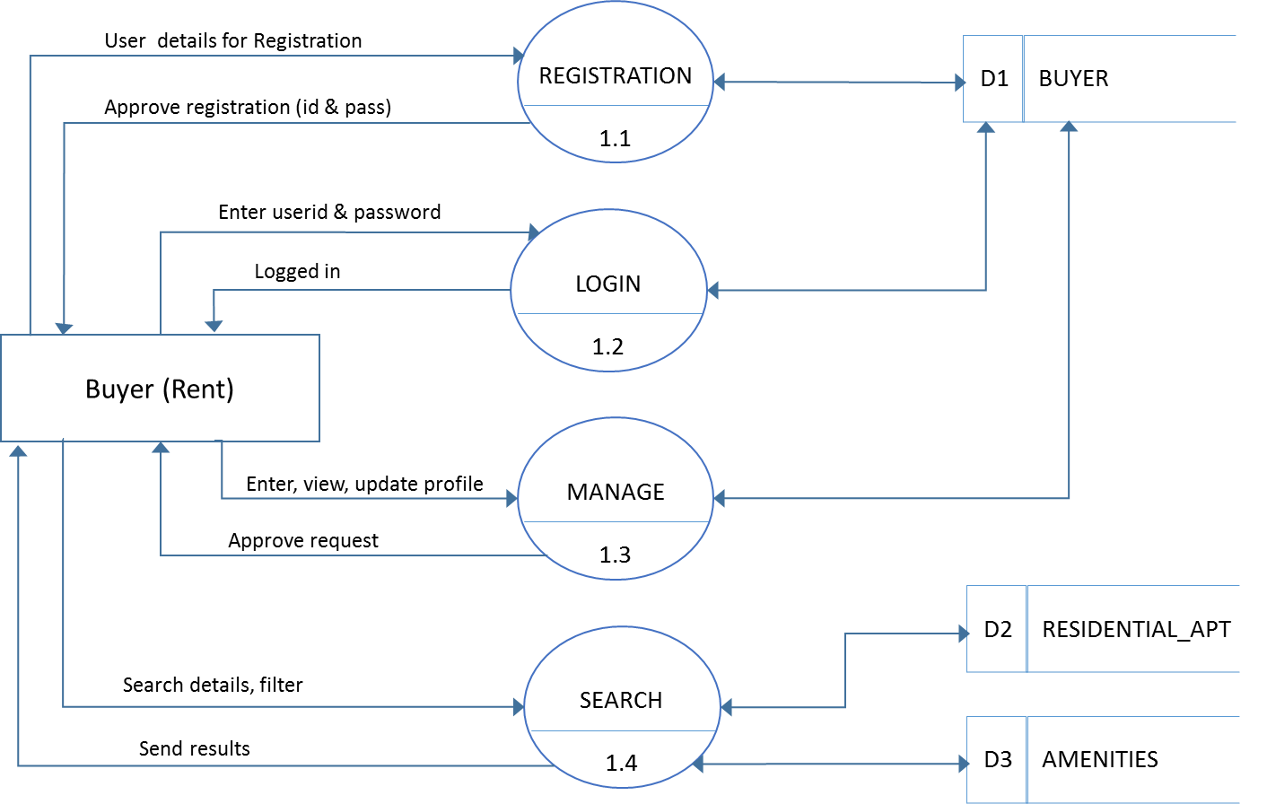

**LEVEL 1: ADMINISTRATOR**

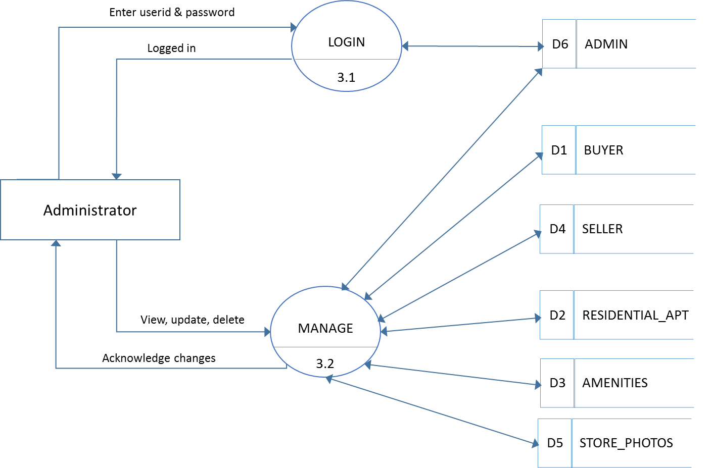

**LEVEL 1: SELLER**

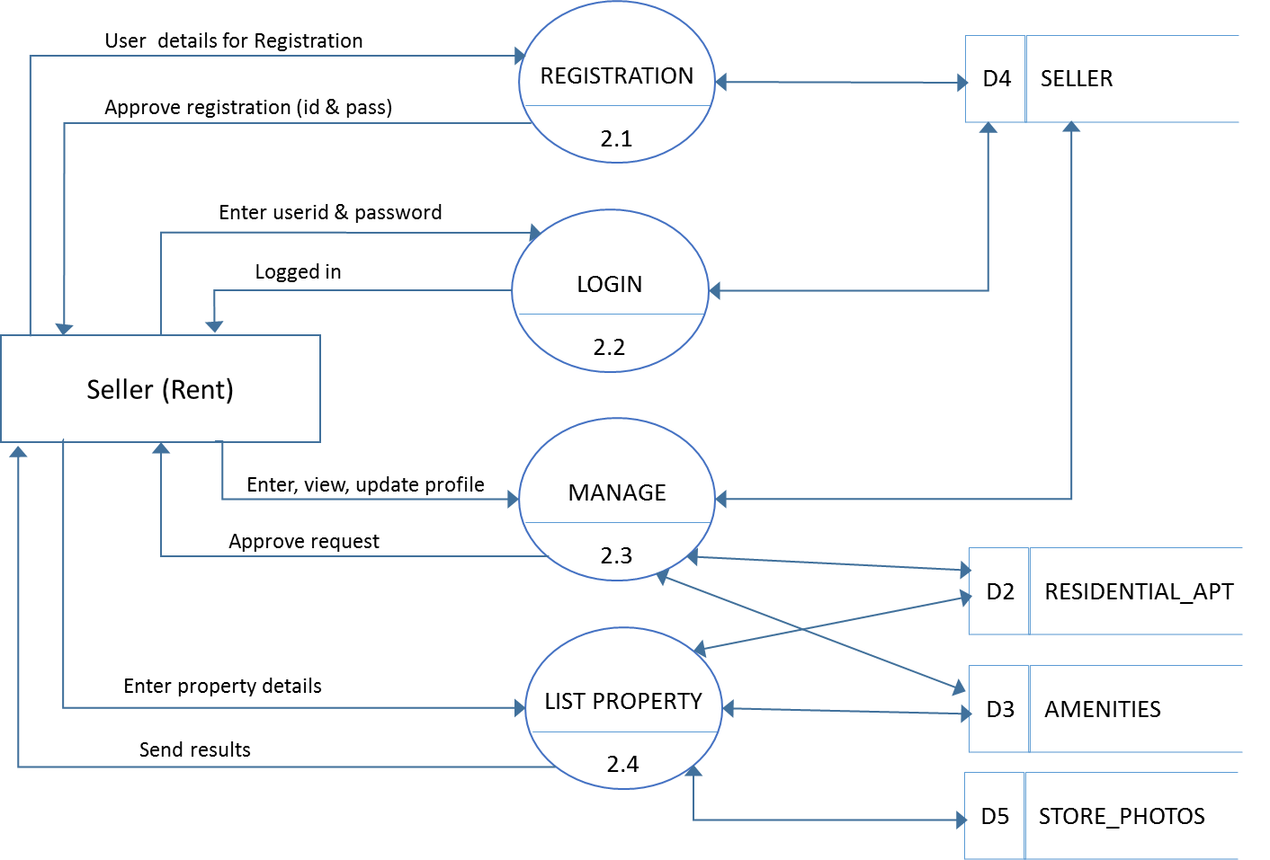

## ER Diagram

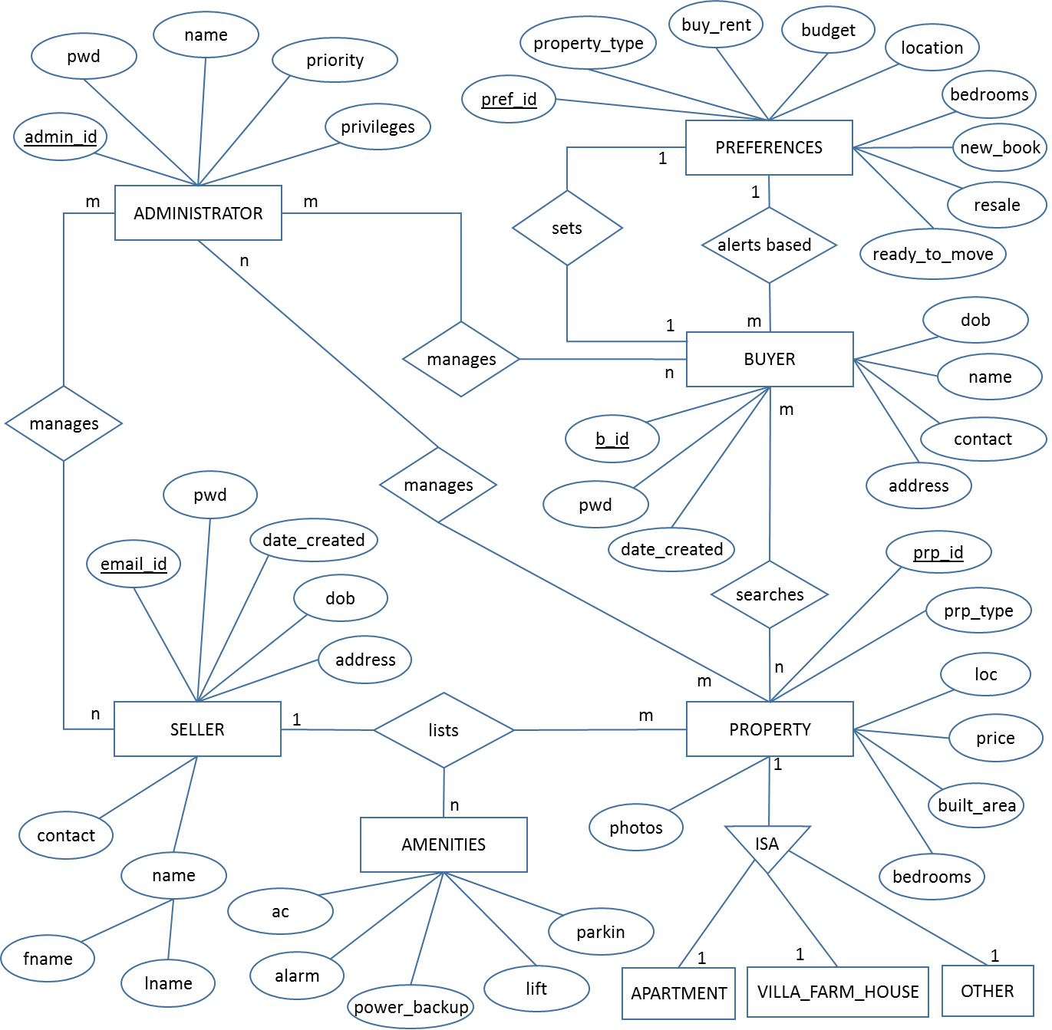

# CHANGE MANAGEMENT PROCESS

Changes to this document may be made after approval from the project manager and the client approval officer.

## FUTURE ENHANCEMENTS

The application developed is designed in such a way that any further enhancements can be done with ease. The system has the capability for easy integration with other systems. New modules can be added to the existing system with less effort.

The features that could be incorporated are:

* Added security to users from fake profiles and property
* Robust system with added processing to deliver faster and enhanced search results.
* Making the system online and approach to more cities in India.
* A marginal fee can be taken to provide advanced search/filter option and faster results.
* Auto-Generated Mailing System informing both the Buyers and the Sellers.
* SMS-Alert.
* The errors occurred due to failure of resources on the website has to be reduce as far as possible to make the site & more user friendly in nature.
* This website should be launched in World Wide Web (www) to have the live version over the internet.
* More modules such as Agent, Builders can be added.

## APPENDICES

### APPENDIX

* Java2 Complete Reference

Author : Herbert Scheldt

Publisher : TMH , Edition –Seventh

* HTML 5 Black Book

Author : Kogent Learning Solutions Inc.

Publisher : Dremtech press

* www.w3school.com (HTML ,AJAX, JavaScript & etc)
* www.roseindia.com
* www.javapractice.com
* www.avajava.com/tutorials
* www.java-samples.com/jsp/
* www.connectionstrings.com/oracle